vinay -- Accenture -- 8595152052

--> Accenture login creds: Accenture@123$

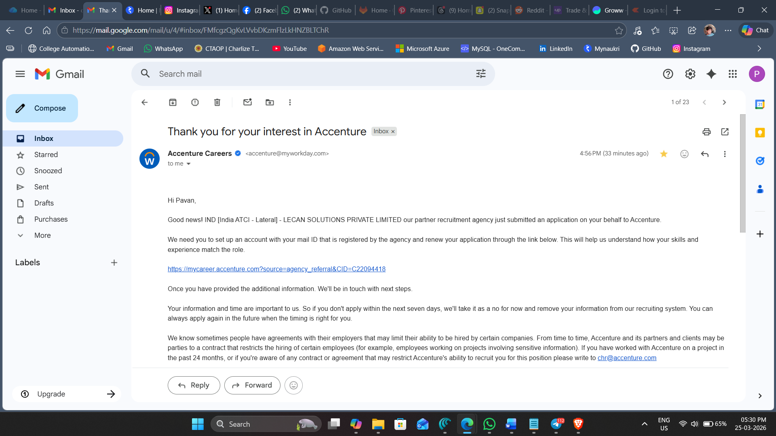

- Simple explaination about bigquery: JD based on BigQuery:
I have around 4+ years of experience working with BigQuery as a data warehouse on Google Cloud. In my projects, I used BigQuery to store large amounts of processed data coming from sources like GCS and Dataflow pipelines. I created tables, designed schemas, and wrote SQL queries to clean, transform, and organize the data. For example, I would take raw sales data, remove errors, and calculate total sales per customer so that business teams could easily use it for reporting.

I also focused a lot on improving performance and reducing cost in BigQuery. I used techniques like partitioning (dividing data by date) and clustering (organizing data by specific columns) to make queries faster and more efficient. I worked with both batch and real-time data pipelines, where BigQuery acted as the final storage layer for analytics dashboards like Power BI or Looker. Overall, I used BigQuery to make data reliable, fast, and ready for business insights.

